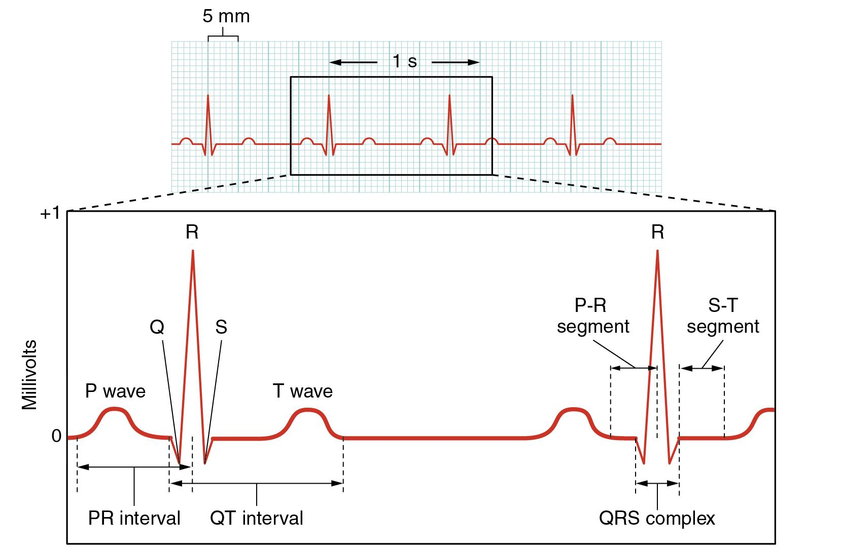

The PR interval incorporates the time from the depolarization of the sinus node to the onset of ventricular depolarization. The measurement starts from the beginning of the P wave to the first part of the QRS complex, with a normal duration between 0.12 to 0.20 seconds.

The normal duration (interval) of the QRS complex is between 0.08 and 0.10 seconds — that is, 80 and 100 milliseconds. When the duration is between 0.10 and 0.12 seconds, it is intermediate or slightly prolonged.

In general, the normal QT interval is below 400 to 440 milliseconds (ms), or 0.4 to 0.44 seconds. Women have a longer QT interval than men. Lower heart rates also result in a longer QT interval. Anything greater than or equal to 0.50 second is considered dangerous for any age or gender;

The QT interval on the ECG is measured from the beginning of the QRS complex to the end of the T wave (see ECG components). It represents the time it takes for the ventricles of the heart to depolarize and repolarize, or to contract and relax.

HOW to measure EKG: http://www.rnceus.com/ekg/ekghowto.html

