**Clinical Post conference Ideas**

Day 1 of Clinicals:

I hope that you enjoyed your first day of clinicals. Tell me about your day using the prompts below. Grow, Glow, Know & Knew. Please provide at least 3 sentences for each.

**Grow**

***This is something that could of been better***

**Glow**

***This is something that went well***

**Know**

***This is something you want to know more about, a diagnosis; procedure, etc.***

**Knew**

**What's something you already knew? Did something come easy to you?**

**Mobility: Post Conference Assignment**

Download the Mobility Worksheet. Once the worksheet has been downloaded on your device you can type inside the worksheet. Make sure to save the worksheet on your computer and name it "Mobility" Then upload the completed worksheet to this assignment for a grade.

Choose a patient that you worked with today at clinicals and complete the Mobility form. Do NOT use any patient identifiers. You may use John Doe or Jane Doe

<https://grayson.instructure.com/courses/39219/files/6568232?wrap=1>

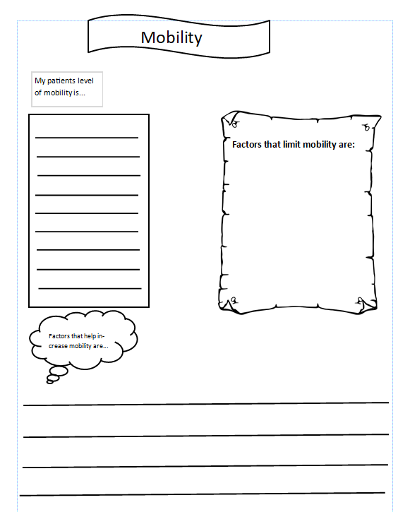

Mastering Intake and Output

Download the Mastering Intake and Output document by clicking this link Mastering Intake & Output-1.docx

Once you have downloaded the document you can type inside the worksheet. Make sure to Save your work to your device and name the worksheet "Mastering Intake and Output"

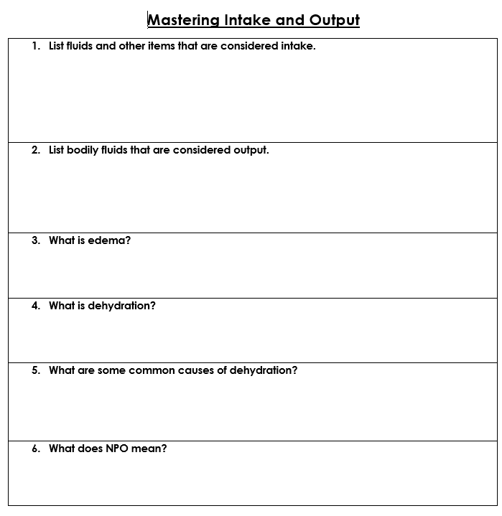

Positioning

Download the positioning clinical journal to your device by clicking this link [Positioning clinical journal.pub](https://grayson.instructure.com/courses/39219/files/6569690?wrap=1)

Once you have downloaded the document you will be able to work inside it.

Make sure to save the document on your device and name it "Positioning clinical journal"

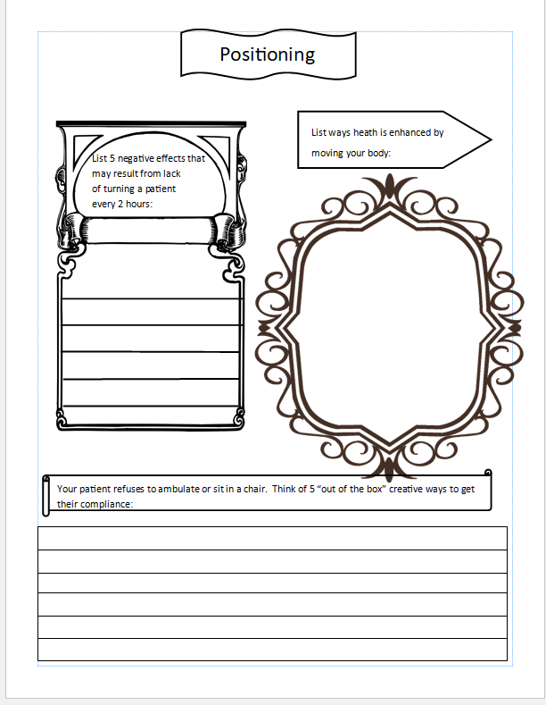

Patient Bathing Clinical Journal

Download the Patient bathing clinical journal by clicking this link [Patient bathing clinical journal.pub](https://grayson.instructure.com/courses/39219/files/6569696?wrap=1)

Once you have downloaded the document to your device you will be able to type inside of it. Make sure to save the document as "Patient bathing clinical journal" then upload it here for a grade *You may document bed bath, chair bathing or patient showers*

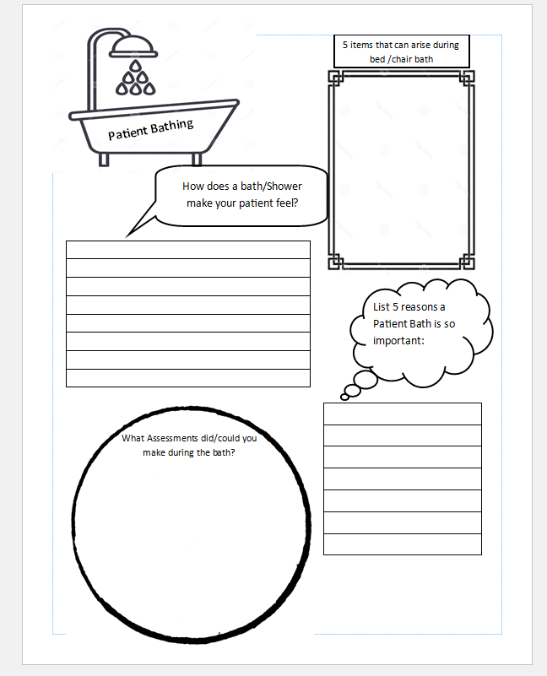

Nutritional Clinical Journal

Download the Nutrition clinical Journal by clicking this link [NUTRITION CLINICAL JOURNAL.pub](https://grayson.instructure.com/courses/39219/files/6569700?wrap=1)

Once you have downloaded this document to your device you'll be able to type inside of it. Make sure to save the document as "Nutrition clinical Journal" and then upload your assignment here.

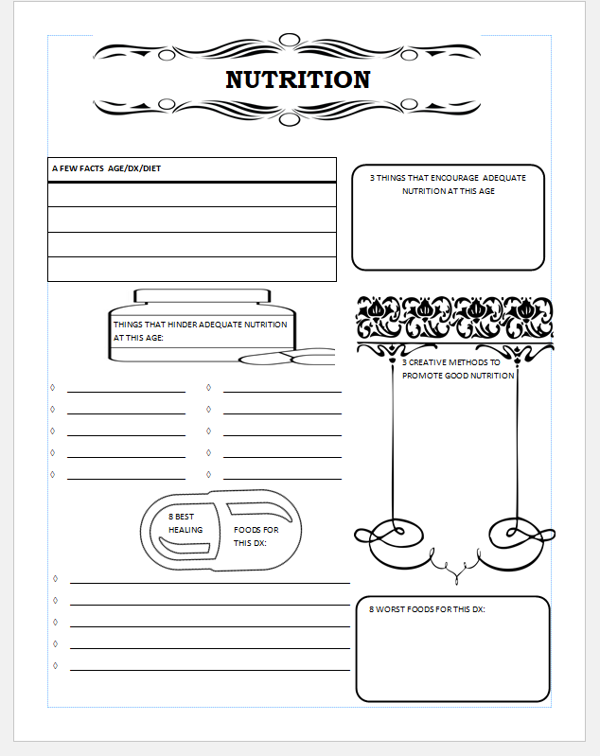

Conclusion of Clinicals

Using Grow, Glow, Know and Knew, complete the questions below. You must have 3 complete sentences for each.

**Grow:**

How did you grow as a CNA ?

**Glow:**

Was their a CNA that "Glowed" (someone that was good at his or her job)   to you ? If so why ?

**Know:**

Was their a CNA you "Know" you would NOT want to be like ? why ?  Where they aggressive with patients? Did they have not have a good bedside manner? etc.

**Knew:**

what are some things you've learned that you "Knew" was the correct way of performing CNA duties that you observed other CNA's NOT doing?