**CNA Skills Check Off**

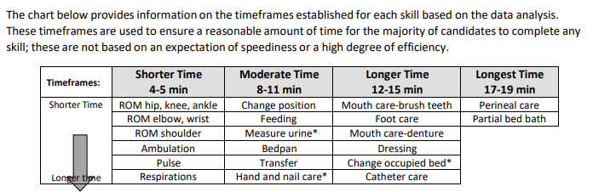

**Students must complete handwashing before the first skill and then they can simulate handwashing between skills**

|  |
| --- |
| **Handwashing** |
| **ROM L Elbow & Wrist** |
| **Pulse +/- 4** |
| **Partial Bed Bath and back rub** |
| **Total Time = 37 Min** |

|  |
| --- |
| **Handwashing** |
| Change position |
| Respirations +/- 2 |
| Occupied Bed |
| Total Time = 40 min |

|  |
| --- |
| Handwashing |
| Change Position |
| Pulse +/- 4 |
| Footcare |
| Total Time = 40 min |

|  |
| --- |
| Handwashing |
| ROM L hip/knee/Ankle |
| Respirations +/- 2 |
| Dressing a Resident weak side L |
| Total Time = 31 min |

|  |
| --- |
| Handwashing |
| Transfer a Resident |
| I&O Urine bag |
| Hand & Nail |
| Total Time = 40 min |

|  |
| --- |
| Handwashing |
| Transfer a Resident |
| Respirations +/- 2 |
| Mouth care & dentures |
| Total Time = 30 min |

|  |
| --- |
| Handwashing |
| Change of Position |
| Respirations +/- 2 |
| Mouth Care brush teeth |
| Total Time = 31 min |

|  |
| --- |
| Handwashing |
| ROM L Shoulder |
| Pulse +/- 4 |
| Partial Bath & back rub |
| Total Time = 37 min |

|  |
| --- |
| Handwashing |
| ROM L Shoulder |
| Respirations +/- 2 |
| Peri Care |
| Total Time = 40 min |
|  |

|  |
| --- |
| Handwashing |
| Transfer a resident |
| I& O urine bag |
| Cath Care |
| Total Time = 40 min |

|  |
| --- |
| Handwashing |
| ROM L hand/wrist |
| Pulse +/- 4 |
| Bed Pan |
| Total Time = 35 min |

|  |
| --- |
| Handwashing |
| Transfer a Resident |
| Respirations +/- 2 |
| Mouth care & dentures |
| Total Time = 30 min |

|  |
| --- |
| Handwashing |
| Feeding a resident |
| Ambulation |
| Mouth care brush teeth |
| Total Time = 35 min |

|  |
| --- |
| Handwashing |
| ROM left Shoulder |
| Measure urine |
| Catheter care |
| Total Time = 31 min |

|  |
| --- |
| Handwashing |
| Feeding |
| ROM elbow, wrist |
| Bedpan |
| Total Time = 41 min |

|  |
| --- |
| Handwashing |
| Respiration +/- 2 |
| Teeth |
| Change position |
| Total Time = 41 min |