Name: My Partner is:

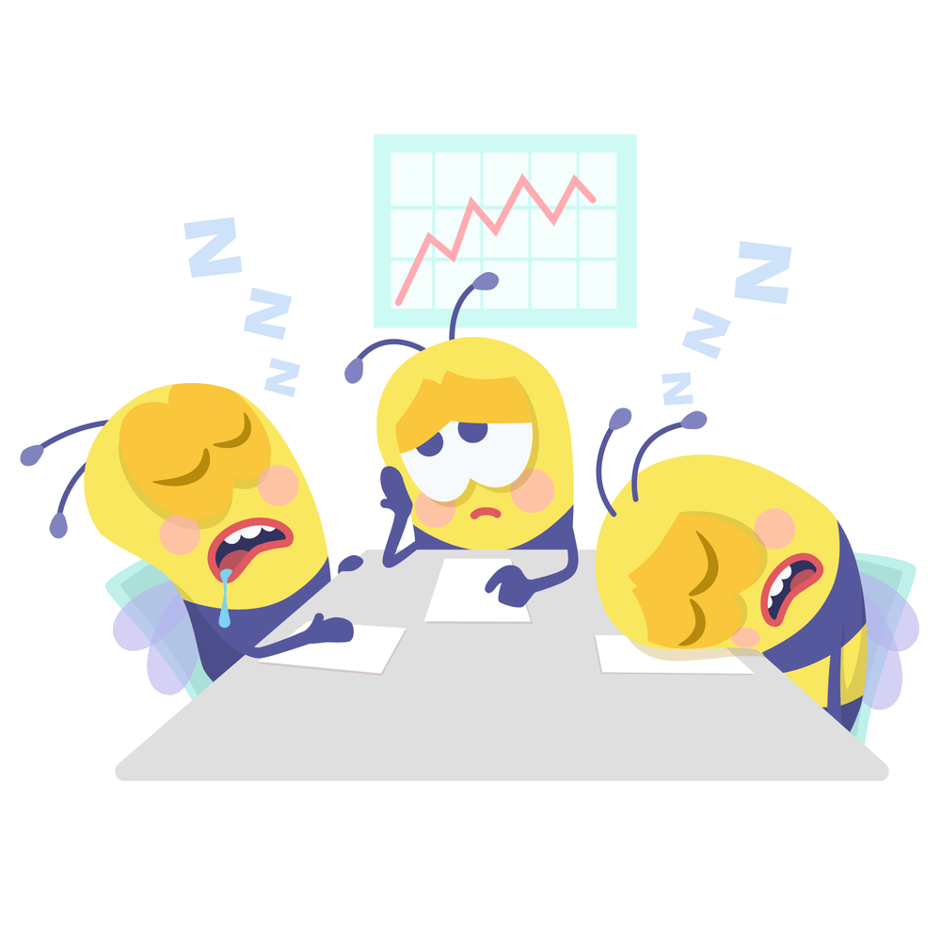Class Period:

Health Career Display

1. Career information should include, but is not limited to:
   1. Job responsibilities
   2. Education requirements
   3. Entry level salary at the local/national/global level
   4. Benefits/challenges associated with this career
   5. Additional relevant information
2. Allowable artwork may include:
   1. Competitor produced illustrations, designs, and/or computer-generated graphics.
   2. Clip art or other graphics used in compliance with copyright laws.
   3. Photographs used in compliance with copyright laws.
   4. Computer or machine generated lettering.
3. Reference Page(s):
   1. List the literature cited to give guidance to the project. American Psychological Association (APA) is the preferred resource in Health Sciences.
   2. The reference page(s) is attached to the back of the display.
   3. Points will be awarded for compiling a clean, legible reference page.
4. The display uses:
   1. a single wall tri-fold presentation display board that is no larger than 36” H x 48” W, in any color, made of foam or corrugated cardboard.
   2. It must be able to stand on a standard conference table furnished on site.
   3. The display may include models, mannequins, pamphlets, brochures, or any other method or combination of physical objects to display the project.
5. Present a five (5) minute prepared oral presentation to the judges.
   1. Use of index card notes during the presentation are permitted. Electronic notecards (on a tablet, smart phone, laptop, etc…) are permitted.
   2. Include:
      1. why they chose this career/career cluster
      2. what they learned by researching this career/career cluster
      3. what forms of research they used to complete the display
      4. what they included on the display and why.
   3. Both team members must take an active role in the presentation.