Power of __

**Today we will approach our time together with the __________________________ . As long as we get ___ good idea today that we can implement in our classroom tomorrow, we will consider the day a success!**

Three elements to students learning at high levels:

1.

2.

3.

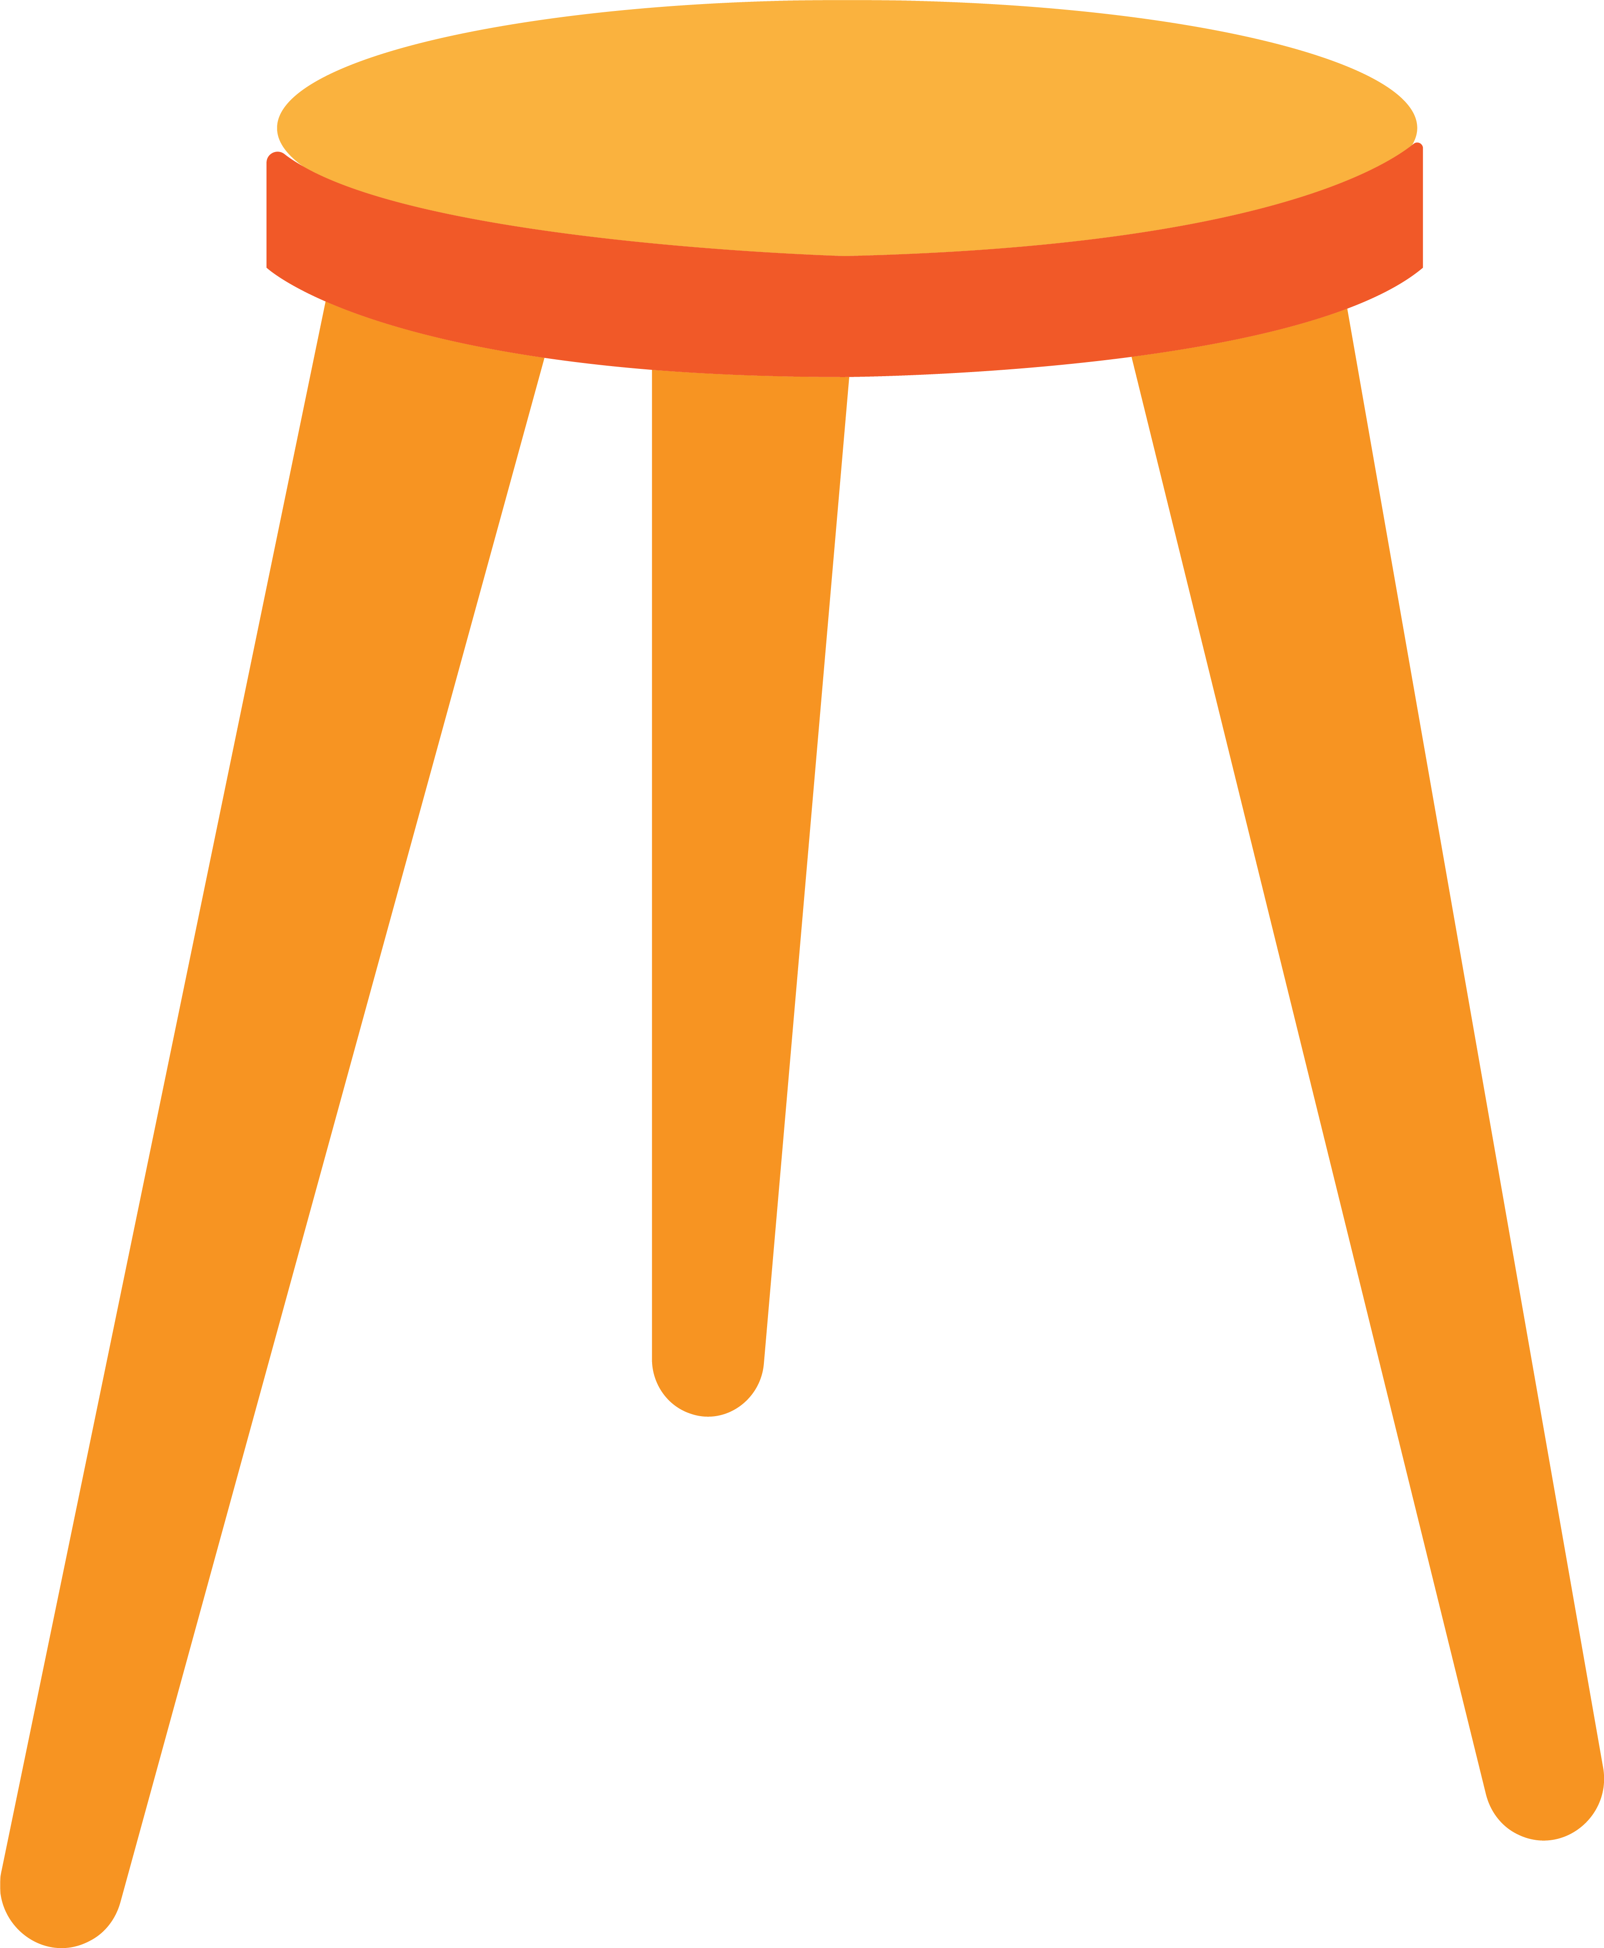

**The Golden Rule Teaching and Learning**

___________________________________________________________________________________________________

**Key point #1**Master teachers shift their classrooms from_____________________________________________.



**Key point #2**

The end goal of ________________________ is for students to be able to __________________ master the knowledge and skills being studied over time and apply them to the __________________.



**“Students know they are treated differently in the classroom due to expectations held by teachers and are quite accurate in informing on how teachers differ in the degree to which they have higher expectations of some children over others.”**

**-Weinstein (2009) & Hattie (2023)**

* Story taken from “Who’s Doing the Work?” by Jan Burkins and Kim Yaris

|  |
| --- |
| **HIGH EXPECTATIONS IN ONE SENTENCE**  Teachers with high expectations tend to hold them for ALL students in the class and successfully raise achievement, whereas those with low expectations are, sadly, also successful in the opposite direction. |
| **what the research says (Hattie, 2023)**  * Low expectations have negative to limited impact on students performance (-0.03 to 0.20) * High expectations have a medium to high positive impact on student performance (0.50 to 1.44) * Low expectations teachers see differentiation in terms of grouping, different activities, and levels of challenge (different exposure to curriculum). * High expectations teachers see differentiation as meaning different times and ways of attaining success. |
| **what does this look like for teachers?**  * All students can make incremental progress, regardless of current level of ability. * Focus on learning as opposed to activities and behaviors. * Build learning opportunities around student interests. |
| **what does this look like for students?**  * Students feel challenged in completing activities. * Students manage themselves regarding procedures and routines. * Student learning is connected to prior knowledge. |
| **what is my takeaway for this instructional strategy?** |
| **Skill Mastery**  **Learning is a three-step process:**   1. **Initial ____________________ of information in short-term working memory.** 2. **____________________ reorganizes and stabilizes memory traces, gives them meaning, makes connection to past experiences and long-term memory.** 3. **____________________ updates learning and enables you to apply it when you need it.**  * Make It Stick – The Science of Successful Learning, Brown, Roediger, and McDaniel (2014). |
| |  |  | | --- | --- | | **ENCODING** |  | | **CONSOLIDATION** |  | | **RETRIEVAL** |  | |
| **Retrieval Practice Challenge Grids** |
| |  |  | | --- | --- | | **MIX UP YOUR PRACTICE** | 1. **_________** practice out over time. 2. **_________** practice to other knowledge (not in isolation). 3. **_________** practicing the fundamentals with all students. 4. **_________** it up in practice because too much repetition is boring. | |  **TAKE QUIZZES** | 1. **_________** retrieval out over time 2. Make them **_________** (not pop) 3. Make the learner supply the **_________** 4. Make them **_________** | | DIFFICULTY** | Ask students to recall information at different **_________**with different **_________** | |  **REFLECT** | * What are the key ideas? * What are some examples? * How does this relate to what I already know? * What went well? What could’ve gone better? * What is the main idea in my own words? * How does this connect to other topics from this class? * How does this connect to other topics from outside this class? |   **A Roadmap for Teaching _____________**   |  |  | | --- | --- | | **This is how the information is introduced to students (encoding).** |  | | **This is how we give meaning to the skill and connect it to long-term memory (consolidation).** |  | | **This is how students practice and apply the skill (retrieval).** |  | | **Reflection: What adjustments would you make to incorporate the 4 strategies discussed (mix it up, quiz, embrace difficulty, reflect)?** | |   **Re-teach and Re-test**  **4 Easy Strategies for Re-teach and Re-test**   1. **Worked Out Examples (My Favorite Mistake)** 2. **Peer Teaching** 3. **ABC Strategy** 4. **Reciprocal Teaching**   **Defining Direct Instruction and Classroom Discussion**   |  |  | | --- | --- | | **Direct Instruction** | **Classroom Discussion** | |  |  |   **3 Stages of Classroom Discussion**   1. **_________ - Students gain a basic understanding of the topic, text, or concept.** 2. **_________- Students experience meaningful “think-aloud” interactions with peers and content to understand the topic at a deeper level.** 3. **_________ - Summative feedback regarding how student participated in the discussion and interaction with the topic.**   **Solving Challenges During Classroom Discussion**   |  |  | | --- | --- | | **Challenge** | **The teacher could…** | | **Student answers are at the surface level.** |  | | **Students are not self-correcting their answers as they go.** |  | | **Students do not stay on topic.** |  | | **Students do not participate or the discussion stalls quickly.** |  | | **Classroom discussion takes too much time.** |  | | **Challenge** | **The teacher could…** | | | **Student answers are at the surface level.** | * **Use probing questions to expand upon first answer –**   + **“That’s interesting. Tell me more about that.”**   + **“We’re with you. Keep going.”**   + **“Tell me why? Justify your answer.”**   + **“Connect this to ________________.”** * **Ask “What if” questions**   + **What might be an alternate way of thinking?**   + **What if…?**   + **Imagine _____. How would this change our thinking?** * **Start with a turn and talk before sharing out as a group.** * **Require preparation for discussion by referring to texts and related topics from class.** | | | **Students are not self-correcting their answers as they go.** | * **Model self-correction for the students by displaying a scripted incorrect response for the class.** * **Summarize what the student said and repeat it back to them. Ask them to justify or elaborate on their thinking.** * **Poll the class on if they agree or disagree with the responses made. Ask them to justify their answer.** | | | **Students do not stay on topic.** | * **Create and follow classroom norms** * **Script focus questions before hand and require students to link their responses to the focus questions. Ask – “In what way does this relate to today’s focus question?”** * **Create a Parking Lot for students** | | | **Students do not participate or the discussion stalls quickly.** | * **Give think time to ensure all students have time to process** * **Start with partner talk before sharing out.** * **Convey your teacher thoughts and ask students to agree/disagree and justify their answer** * **Pose a new question.** * **Track patterns of participation as you go.** * **Have students reflect on level of participation at the end of class.** | | | **Classroom discussion takes too much time.** | * **Start with partner talk before sharing out.** * **Use a timer to limit answers and “thinking out loud”** * **Have students script out responses and be prepared to share out prior to discussion.** | |   **Sample Classroom Discussion Reflection Tool**   |  |  |  | | --- | --- | --- | | Record each skill we focused on today for our classroom discussion. Rate yourself as:  **NW (Needs Work)**  **OK (Acceptable)**  **VS (Very Skilled)** | | | | **Skill Area Focus** | **My Performance** | **Class or Group Performance** | | Contribute equally to the discussion. | VS – I spoke, but not too much. I think I made a good point. | OK – Not everyone participated in the discussion | | Ask questions to clarify what others say. | OK – I didn’t need to ask questions to clarify. I understood what everyone said. | OK – A couple of people did ask someone to give examples and to explain their thinking. | | Ask others what they think so we hear from all participants. | VS – I was nervous to ask Luiz what he thought because he hadn’t said anything. I asked him what he thought and he had a good response! | NW – I was the only one who asked someone what they thought. | | Adapted from Questioning for Classroom Discussion, by Walsh and Sattes (2015). | | | |
|  |
| **CLASSROOM DISCUSSION IN ONE SENTENCE**  Classroom discussions can be a way for teachers to hear feedback and for students to engage in a dialogue of learning, hearing alternative interpretations, and becoming more engaged in the learning process (Hattie, 2023). |
| **what the research says**  * Classroom discussion is rare. Researchers estimated that about 2/3 of talking in class is done by the teacher, and 2/3 of teacher talk is direct instruction (Hattie, 2023). * The dominant form of instruction is a 3-step process: teacher asks a question, a student responds, the teacher evaluates (Nystrand, et al., 2001). |
| **what does this look like for teachers?**  * Classroom discussion looks more like volleyball, and less like tennis. * Teachers “prime” the class by ensuring students have a basic understanding of the topic, text, or concept. * Teachers may answer a question with a question. |
| **what does this look like for students?**  * There are norms in place to ensure all students participate. * Students know how to refer to their resources during the class discussion. * Students reflect at the end of classroom discussion. |
| **what is my takeaway for this instructional strategy?** |

**Scaffolding**

Coach Ferguson’s Class is going to study an informational text reading on the Articles of Confederation. The objective is for students to analyze the reading to gain a greater understanding of Articles of Confederation, how the 13 states viewed unification under a single national government, and strengths/weaknesses of the Articles of Confederation.

**Lesson #1**

* Before the activity, Coach Ferguson reviews a list of 10 vocabulary words in the article that may be difficult for students and their definitions.
* Coach Ferguson calls on individual students to read paragraphs. They are asked to highlight information they believe is important. The teacher summarizes each paragraph to ensure students do not miss key points.
* After the reading and class discussion, pairs of students complete a short quiz to test their understanding of the information from the article.
* While pairs of student work on the quiz, Coach Ferguson pulls a group of inclusion students to the teacher table for a re-reading of the passage to ensure understanding. They complete the quiz together. Students read the text on their own and highlight terms they do not know.

**Lesson #2**

* Coach Ferguson walks around and identifies highlighted terms.
* When students are finished, the text will be read whole group and teacher will explain those terms in the context they are used.
* After the reading and class discussion, pairs of students complete a short quiz to test their understanding of the information from the article.

**Lesson #3**

* Students pre-read and annotate the text in pairs.
* When students are finished, the text will be read whole group and teacher will explain those terms in the context they are used.
* After the reading and class discussion, pairs of students complete a short quiz to test their understanding of the information from the article.

**Scaffolding Research**

The zone of proximal development (Vygotsky, 2012) involves teachers and students recognizing a gap between what a learner accomplishes along and what can be accomplished with assistance of an expert. Thus, the learner needs scaffolding from experts to reduce the gap, but the extent and specificity of this help need to reduce over time – hence, the notion of the teacher’s gradual release of responsibility such that when reaching toward the success criteria, the scaffolding fades or stops as students are finally able to complete a task or resolve a problem without any support or assistance from external aids or assistance. At high level of scaffolding, there can be Direct Instruction, provision of worked examples, and modeling of thinking aloud, but then the skill of the teacher is to fade this support, which thus involves careful evaluation of where students are relative to success (doing it themselves), the student’s skills to identify and word through errors and missteps, and the self-regulation skills to become their own teacher.

* **Hattie, 2023, p. 381**

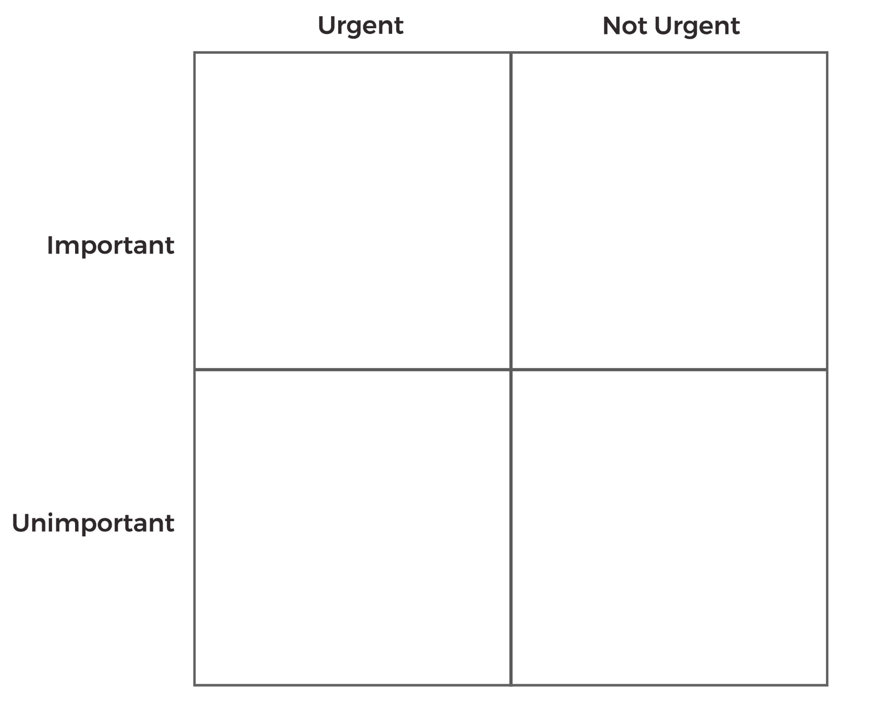

Takeaways from Today

**2 + 2 + 1**

**2 dates on the calendar I will set to check my progress**

**2 topics I am going to work on**



**+**

**+**

**1 trusted person I will ask for feedback**



N

W

E

S

COMPASS ROSE PARTNERS